Cloud Storage Providers
- Amazon S3 ( very imp)
- Google Big table Data store
- Mobile Me
- Live Mesh
Amazon S3: Amazon Simple Storage Service (Amazon S3)
Amazon Simple Storage Service (Amazon S3) is an object storage service that offers industry-leading scalability, data availability, security, and performance. This means customers of all sizes and industries can use it to store and protect any amount of data for a range of use cases, such as data likes, websites, mobile applications, backup and restore, archive, enterprise applications, IoT devices, and big data analytics.
Design Requirements in Amazon S3:
- Scalable
Amazon S3 can scale in terms of storage, request rate, and users to support an unlimited number of web-scale applications.
- Reliable
Store data durably, with 99.99 percent availability. Amazon says it does not allow any downtime.
- Fast
Amazon S3 was designed to be fast enough to support high-performance applications. Server-side latency must be insignificant relative to Internet latency. Any performance bottlenecks can be fixed by simply adding nodes to the system.
- Inexpensive
Amazon S3 is built from inexpensive commodity hardware components.
- Simple
Building highly scalable, reliable, fast, and inexpensive storage is difficult. Doing so in a way that makes it easy to use for any application anywhere is more difficult. Amazon S3 must do both.
Design Principles:
• Decentralization It uses fully decentralized techniques to remove scaling bottlenecks and single points of failure.
• Autonomy The system is designed such that individual components can make decisions based on local information.
• Local responsibility each individual component is responsible for achieving its consistency;
• Controlled concurrency Operations are designed such that no or limited concurrency control is required.
• Failure toleration The system considers the failure of components to be a normal mode of operation and continues operation with no or minimal interruption.
• Controlled parallelism parallelism can be used to improve performance and robustness of recovery or the introduction of new nodes.
• Small, well-understood building blocks Do not try to provide a single service that does everything for everyone, but instead build small components that can be used as building blocks for other services.
• Symmetry Nodes in the system are identical in terms of functionality, and require no or minimal node-specific configuration to function.
• Simplicity The system should be made as simple as possible.

How S3 Works
Amazon, S3’s design aims to provide scalability, high availability, and low latency at commodity costs. S3 stores arbitrary objects at up to 5GB in size, and each is accompanied by up to 2KB of metadata. Objects are organized by buckets. Each bucket is owned by an AWS account and the buckets are identified by a unique, user-assigned key.
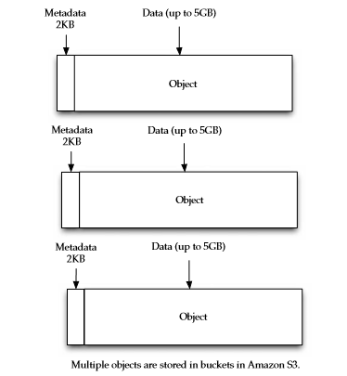
Buckets and objects are created, listed, and retrieved using either a REST-style or SOAP interface. Objects can also be retrieved using the HTTP GET interface or via Bit Torrent. An access control list restricts who can access the data in each bucket.
To upload your data (photos, videos, documents etc.) to Amazon S3, you must first create an S3 bucket in one of the AWS Regions. You can then upload any number of objects to the bucket.

Security:
Amazon S3 supports both server-side encryption (with three key management options (SSE-KMS, SSE-C, SSE-S3) and client-side encryption for data uploads. Amazon S3 offers flexible security features to block unauthorized users from accessing your data.

